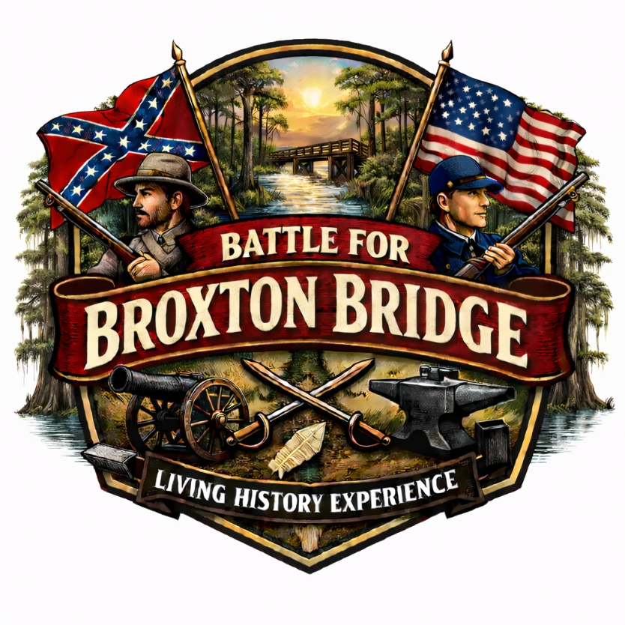
Battle for Broxton Bridge – Living History Program
This document provides expanded educational context for each living history station. It is intended for teachers, docents, and chaperones.

Station 1. Confederate Generals
Generals influenced morale, strategy and how the war is remembered.

Station 2. Field Chaplain

Station 3. Confederate Manual of Arms
Military drill built discipline and unit coordination.

Station 4. The H.L. Hunley
The H.L. Hunley was the first submarine to sink an enemy warship, marking a turning point in naval war.

Station 5. Weaponry Demonstration (Musket)
Muskets were slow-loading firearms that shaped battlefield tactics and required discipline and training.

Station 6. Civil War Hospitals
Medical care was limited, and disease claimed many lives.

Station 7. Spinning Demonstration

Station 8. Open Fire Cage Cooking
Traditional foodways reflect cultural survival.

Station 9. Artillery
Cannons increased the destructive power of Civil War battles.

Station 10. Cavalry Exhibition
Mounted soldiers relied on horses for speed and effectiveness.

Station 11. Broxton Bridge Church

Station 12. Union Camp Life
Camp life included cooking, drilling, repairing clothing, and writing letters home.

Station 13. Blacksmith Demonstration
Blacksmiths produced essential tools and repairs.

Station 14. Broxton Bridge Post Office

